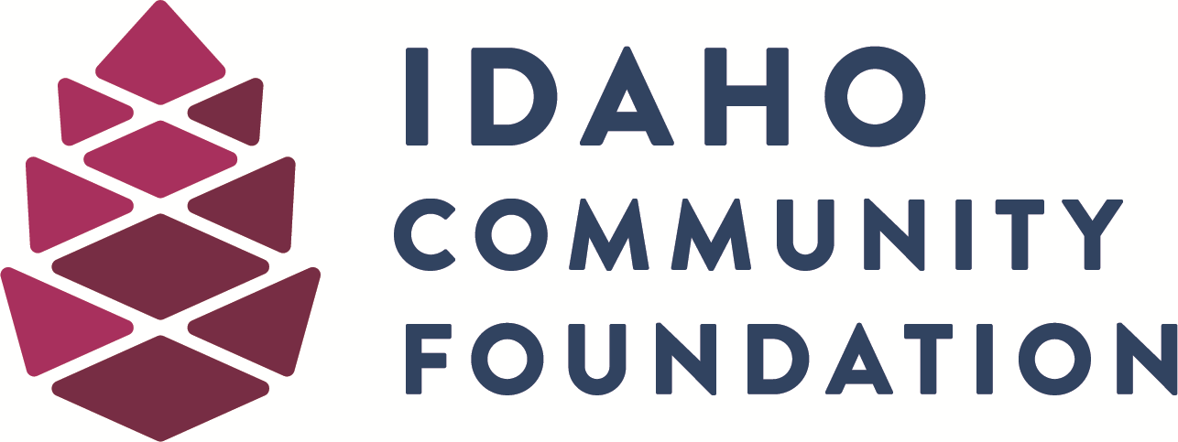



PAUL REBHOLTZ MEMORIAL SCHOLARSHIP

Paul Rebholtz graduated from Boise High School in 1985. He continued his education at Santa Clara University where he loved playing football and the camaraderie of sports. He furthered his education at Northwestern University’s Kellogg Business School.

Paul died in October 2001 as a result of an airplane accident.

Paul was an athlete, an entrepreneur and a successful businessman. But more importantly, he was an affectionate and loving father to his young children, encouraging them to explore and learn. He and his wife, Amy, shared an unconditional and selfless love—Amy was the love of his life. Paul had a world of friends, and they will always remember his smile.

Through the Paul Rebholtz Memorial Scholarship, Paul’s family and friends will keep alive the qualities that are a part of Paul’s legacy: love of family, friends and community; love of sports and learning; the power of faith; and compassion and understanding for others’ needs.

Paul saw the potential in everyone and through his example encouraged others to be the best they could be. This scholarship is to help students who have begun to discover their potential—and to help them be all they can be.

Paul Rebholtz Memorial Scholarship
Deadline: March 15th

The Paul Rebholtz Memorial Scholarship may be used for expenses relating to educational opportunities at colleges and universities, as well as trade and technical schools. The scholarship amount is $1,000 per academic year for up to four years. Scholarships will be paid per semester or quarter. Timing of funding may vary for trade or technical school students, according to the course duration.

The Purpose of this scholarship is to help fund educational opportunities for students who have learned to value knowledge and education through their personal and academic growth during their years at Boise High School.

Improved Performance: Students who have made a good effort to improve their performance during their high school years are encouraged to apply for this scholarship. This scholarship does not heavily emphasize overall grade point average, rather the record of improvement.

A Chance to Succeed: This scholarship is intended to give students who may not meet the strict criteria for typical scholarships a chance to further their education and training.

Making a Difference: Students who have a desire to make a difference in the lives of others, who are ethical, have integrity, who wants to better themselves through education and training are encouraged to apply for this scholarship.

Required materials for the Paul Rebholtz Memorial Scholarship include:

• Complete the attached scholarship application.
• Provide a copy of your high school transcript.
• Provide three letters of recommendation: two from Boise High School teachers, and one from a family member or friend. (Please have the family member or friend identify who they are.)

Email completed applications to Scholarships@idahocf.org no later than 11:59pm MST on March 15. Your email submission must contain this application form and the additional materials listed above in a single PDF attachment. Google docs will not be accepted.

The winner will be contacted by email.

Paul Rebholtz Memorial Scholarship Application
Student Name:
Address:

Home Telephone: | Date of Birth:
Email:

Father’s/Guardian’s Name: | Mother’s/Guardian’s Name:
1. What experience or event during your high school years has had the greatest impact on your life, and in what way has it changed you?
2. Describe an experience about family or friendship that has made you a better person, or an experience where faith has made you stronger:
3. List your top three reasons for wanting to attend college or trade school:
4. List the top three goals you would like to reach in life:
5. Describe one of your most difficult jobs. Explain how you handled it, and in what way the experience has motivated you:
6. What advice would you give to younger students about school and life?
7. List the schools to which you have applied (or intend to apply). Indicate whether you have been accepted and which one you plan to attend (if you have made that decision).

I agree that if selected as the recipient of this scholarship, I will comply with all conditions of the award and will use any funds received for tuition, textbooks, tools or equipment for my education in the year immediately following my high school graduation. I understand that funds issued for this scholarship will be sent directly to the institution of my choice.

I further understand that to receive this scholarship in subsequent years, I must remain enrolled in the institution and submit an annual statement to the Paul Rebholtz Scholarship Committee explaining how the scholarship has helped me and requesting continued funding. I understand I may be invited to participate on the Scholarship Committee to help select future scholarship recipients.

By submitting this application (written or electronically) I consent to the gathering, use and releasing of my information by the Idaho Community Foundation as it relates to the funding of the scholarships. I understand the information is needed for the purpose of the scholarship payments and for normal business operations of the agency. This consent is valid for three years from the date signed, unless I revoke this consent, in writing, to the extent of the information already shared. I certify that the information provided is complete and accurate to the best of my knowledge. Falsification of information may result in termination of any scholarship granted.

Signed:__________________________________ Date:_______________________

